While I assume most of us are already aware and are using this feature to control report execution based on roles assigned to a user but I would still like to share the step by step of accomplishing the same as it could be helpful for some newbies or other professionals who are not aware of this feature.
This kind of requirement can be met by making use of two concepts:
a) Executing Report using a Springboard Icon
b) Use Expression Language to control accessibility of report.
In this example we will demonstrate the following:
- All Employees who have the seeded Employee Roles will be able to access a report (PersonAbsence Accrual Detail) E
- Only Employees who have Line Manager role assigned will have access to (Accrual Detail)
For this example, we will use a pre-existing report. The high-level steps to include:
Create a New Group Under Tools -> Configuration and use a EL Expression on the Visible property to ensure the Group is only visible to users having "PER EMPLOYEE ABSTRACT"
- Create a New Page Entry under the newly created group and use a EL Expression on the Visible property to ensure the Group is only visible to users having "PER EMPLOYEE ABSTRACT" to users
- Create a New Page Entry under the newly created group and use a EL Expression on the Visible property to ensure the Group is only visible to users having "PER_LINE_MANAGER_ABSTRACT"
Creating "Employee Only" Reports
One would need to enable a Sandbox and then use below navigation: Navigator->Configuration->Structure->Create->Create Group
- Attribute Name: * Name
- Attribute Value: Employee Only Reports
- Show on Navigator: EL Expression #{securityContext.userInRole['PER_LINE_MANAGER_ABSTRACT'])

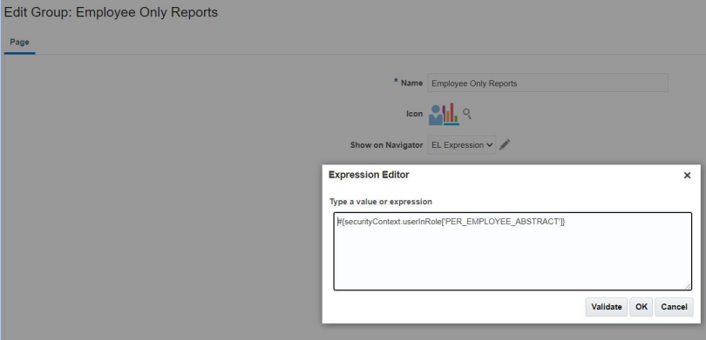
Creating "PersonAbsenceAccrualDetail" Page
We will create a page entry which will be used to call "PersonAccrual DetailReport" which should be visible to all employees. Properties of the Page will be as follows:

Attribute Name | Attribute Value
*Name | PersonAbsence Accrual Details
*Group | Employee Only Reports
Show on Navigator | EL Expression #{securityContext.userInRole['PER_EMPLOYEE_ABSTRACT']}
Show on Springboard | EL Expression #securityContext.userInRole['PER_EMPLOYEE_ABSTRACT']}
Mobile Enabled | Yes
Link Type | Static URL
*Destination | #{EndPointProvider.externalEndpointByModuleShortName['bipServer']}/Custom/Practice+Samples/GetPersonAccrualData.xdo?_xmode=2

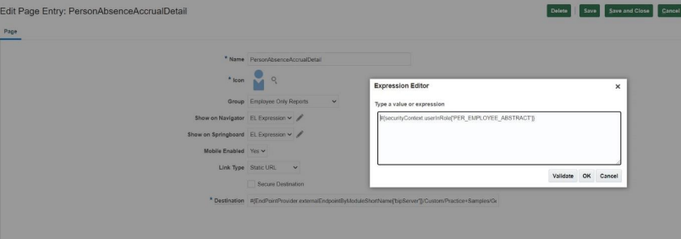

Creating "AccrualDetail" Page
We will create a page entry which will be used to call "AccrualDetail" which should be visible to line managers. Properties of the Page will be as follows:

Attribute Name | Attribute Value
*Name | AccrualDetails
*Group | Employee Only Reports
Show on Navigator | EL Expression #{securityContext.userInRole['PER_LINE_MANAGER_ABSTRACT']}
Show on Springboard | EL Expression #{securityContext.userInRole['PER_LINE_MANAGER_ABSTRACT']}
Mobile Enabled | Yes
Link Type | Static URL
*Destination | #{EndPointProvider.externalEndpoint By Module ShortName['bipServer']}/Custom/Practice+Samples/GetPersonAccrualData.xdo?_xmode=2

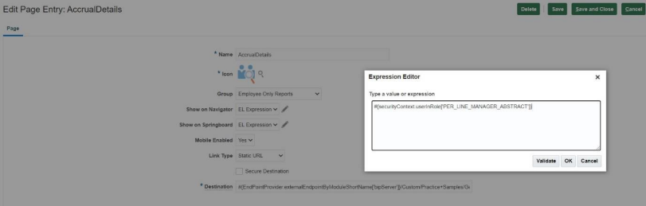
Once the setup is complete we can publish the sandbox.
Verification: Employee Login
We will login to application Login to as SANDY.KIM who is an employee and check results

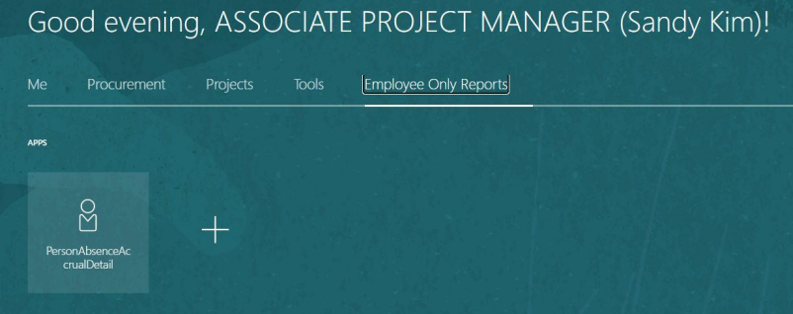

Verification: Line Manager Login
We will login to application as AMY.MARLIN who is both an employee and a line manager and check results
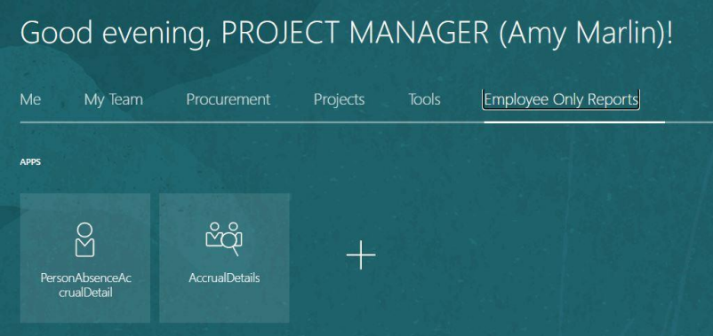

Conclusion
So this is how we can control accessibility and execution of reports based on roles assigned to user. Here, Amy Marlin is both a Line Manager and Employee having both the roles and hence she is able to access and execute both the reports while Sandy. Kim is an employee and not a manager and so she can only access the report designed to be used sed by employees.
The same concept can be extended to specific users too such that a report will be accessible to only one user and not to another.

BY- Shubham Badgujar

